**Name - Divyani Khade**

**Batch - 6th Feb Python Fullstack with data science**

**Date - 24th April, 2025**

1. **Output -**

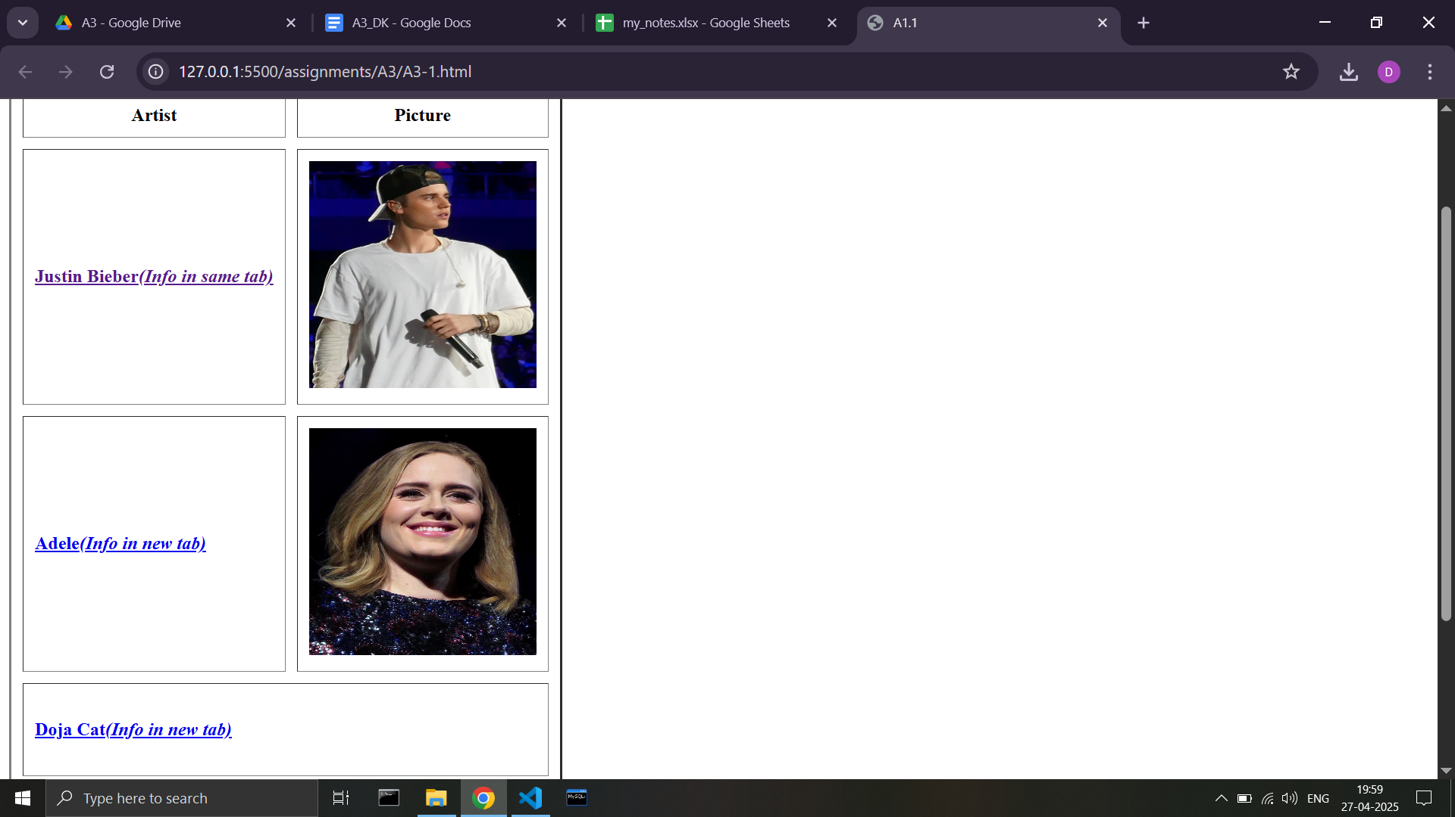

**Code -**

**<!DOCTYPE html>**

**<html lang="en">**

**<head>**

**<meta charset="UTF-8">**

**<meta name="viewport" content="width=device-width, initial-scale=1.0">**

**<title>A1.1</title>**

**</head>**

**<body>**

**<h2>Hobby : Music</h2>**

**<h4>My Favorite Artists :</h4>**

**<table border="2" cellspacing="10" cellpadding="10">**

**<tr>**

**<th>Artist</th>**

**<th>Picture</th>**

**</tr>**

**<tr>**

**<td>**

**<a href="https://en.wikipedia.org/wiki/Justin_Bieber">**

**<h4>Justin Bieber<i>(Info in same tab)</i></h4>**

**</a>**

**</td>**

**<td>**

**<img src="https://i.postimg.cc/MKrST6kQ/Justin-Bieber-in-2015.jpg" alt="image not found" height="200px" width="200px">**

**</td>**

**</tr>**

**<tr>**

**<td>**

**<a href="https://en.wikipedia.org/wiki/Adele" target="_blank">**

**<h4>Adele<i>(Info in new tab)</i></h4>**

**</a>**

**</td>**

**<td>**

**<img src="https://i.postimg.cc/JhxMcbDs/Adele-2016.jpg" alt="image not found" height="200px" width="200px">**

**</td>**

**</tr>**

**<tr>**

**<td colspan="2">**

**<a href="https://en.wikipedia.org/wiki/doja_cat" target="_blank">**

**<h4>Doja Cat<i>(Info in new tab)</i></h4>**

**</a>**

**</td>**

**<!-- <td>**

**<img src="doja_cat_img.jpg" alt="image not found" height="200px" width="200px">**

**</td> -->**

**</tr>**

**<tr>**

**<td>**

**<a href="https://en.wikipedia.org/wiki/Taylor_Swift" target="_blank">**

**<h4>Taylor Swift<i>(Info in new tab)</i></h4>**

**</a>**

**</td>**

**<td rowspan="2">**

**<img src="taylor_swift_img.jpg" alt="image not found" height="200px" width="200px">**

**</td>**

**</tr>**

**<tr>**

**<td>**

**<a href="https://en.wikipedia.org/wiki/Maroon_5" target="_blank">**

**<h4>Maroon 5<i>(Info in new tab)</i></h4>**

**</a>**

**</td>**

**<!-- <td>**

**<img src="maroon_5_img.jpg" alt="image not found" height="200px" width="200px">**

**</td> -->**

**</tr>**

**</table>**

**</body>**

**</html>**

1. **Output -**

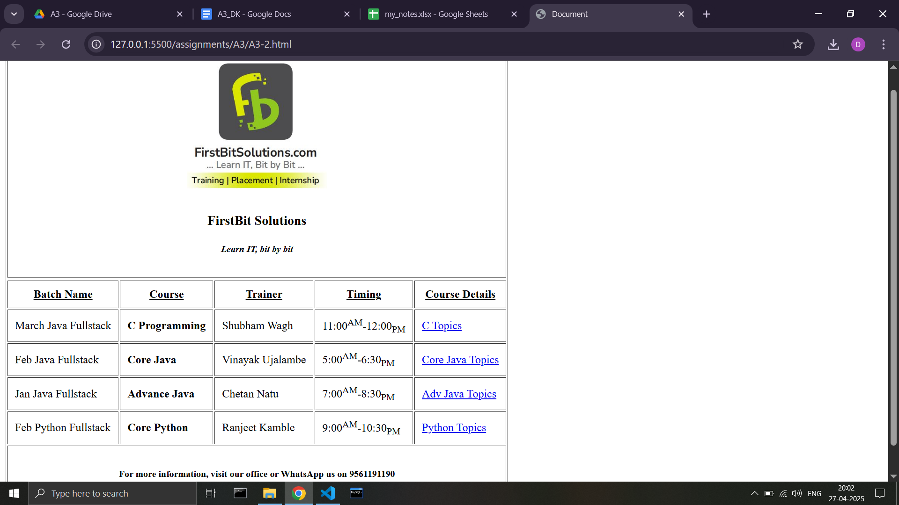

**Code -**

**<!DOCTYPE html>**

**<html lang="en">**

**<head>**

**<meta charset="UTF-8">**

**<meta name="viewport" content="width=device-width, initial-scale=1.0">**

**<title>Document</title>**

**</head>**

**<body>**

**<table border="1" cellspacing="2" cellpadding="10">**

**<tr align="center">**

**<td colspan="7">**

**<img src="https://i.postimg.cc/9FLzZYBS/logo.jpg" height="200px" width="200px">**

**<h3>FirstBit Solutions</h3>**

**<h5><i>Learn IT, bit by bit</i></h5>**

**</td>**

**</tr>**

**<tr>**

**<tr>**

**<th><u>Batch Name</u></th>**

**<th><u>Course</u></th>**

**<th><u>Trainer</u></th>**

**<th><u>Timing</u></th>**

**<th><u>Course Details</u></th>**

**</tr>**

**<tr>**

**<td>March Java Fullstack</td>**

**<td><b>C Programming</b></td>**

**<td>Shubham Wagh</td>**

**<td>11:00<sup>AM</sup>-12:00<sub>PM</sub></td>**

**<td><a href="c_topics.html" target="_blank">C Topics</a></td>**

**</tr>**

**<tr>**

**<td>Feb Java Fullstack</td>**

**<td><b>Core Java</b></td>**

**<td>Vinayak Ujalambe</td>**

**<td>5:00<sup>AM</sup>-6:30<sub>PM</sub></td>**

**<td><a href="core_java_topics.html" target="_blank">Core Java Topics</a></td>**

**</tr>**

**<tr>**

**<td>Jan Java Fullstack</td>**

**<td><b>Advance Java</b></td>**

**<td>Chetan Natu</td>**

**<td>7:00<sup>AM</sup>-8:30<sub>PM</sub></td>**

**<td><a href="adv_java_topics.html" target="_blank">Adv Java Topics</a></td>**

**</tr>**

**<tr>**

**<td>Feb Python Fullstack</td>**

**<td><b>Core Python</b></td>**

**<td>Ranjeet Kamble</td>**

**<td>9:00<sup>AM</sup>-10:30<sub>PM</sub></td>**

**<td><a href="python_topics.html" target="_blank">Python Topics</a></td>**

**</tr>**

**<tr>**

**<td colspan="5" align="center"><h5><b>For more information, visit our office or WhatsApp us on 9561191190</b></h5></td>**

**</tr>**

**</tr>**

**</table>**

**</body>**

**</html>**

**C Topics page -** 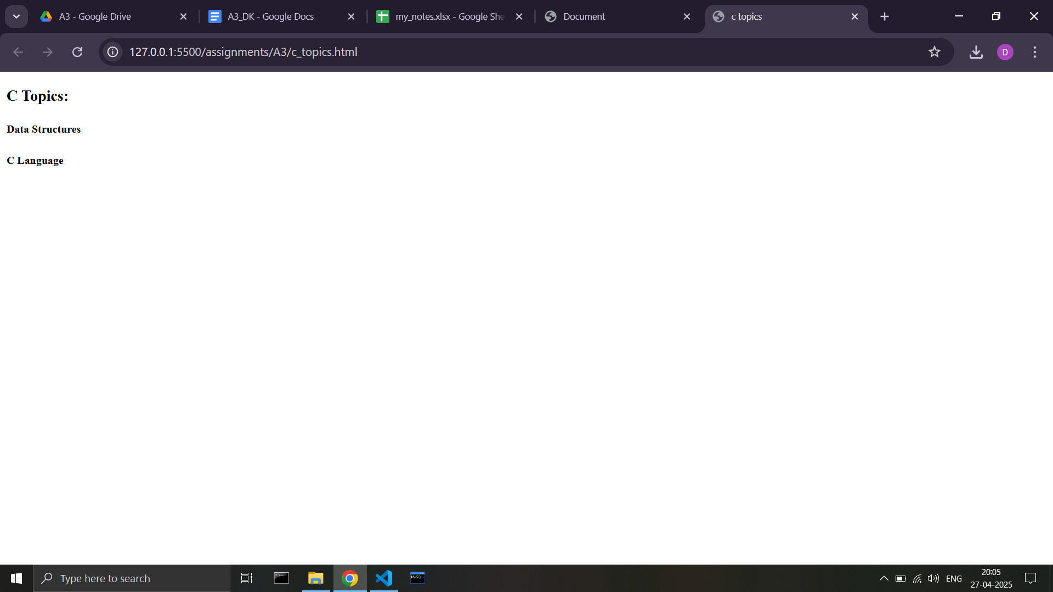

**Code -**

**<html lang="en">**

**<head>**

**<title>c topics</title>**

**</head>**

**<body>**

**<h3>C Topics:</h3>**

**<h5>Data Structures</h5>**

**<h5>C Language</h5>**

**</body>**

**</html>**

**Core Java Topics page -**

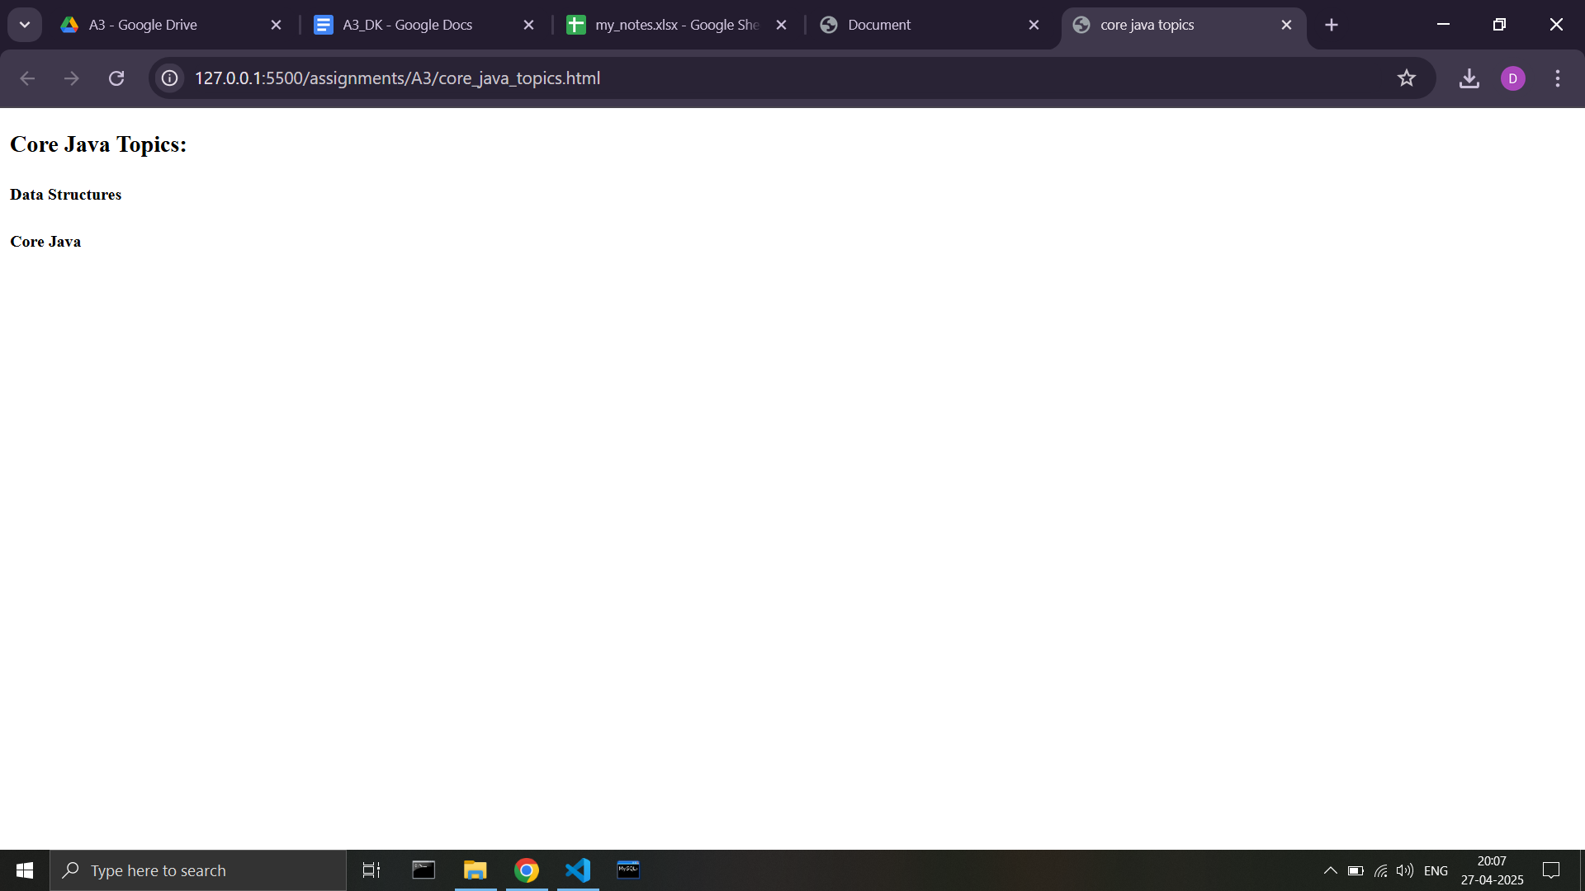

**Code -**

**<html lang="en">**

**<head>**

**<title>core java topics</title>**

**</head>**

**<body>**

**<h3>Core Java Topics:</h3>**

**<h5>Data Structures</h5>**

**<h5>Core Java</h5>**

**</body>**

**</html>**

**Advanced Java Topics page -**

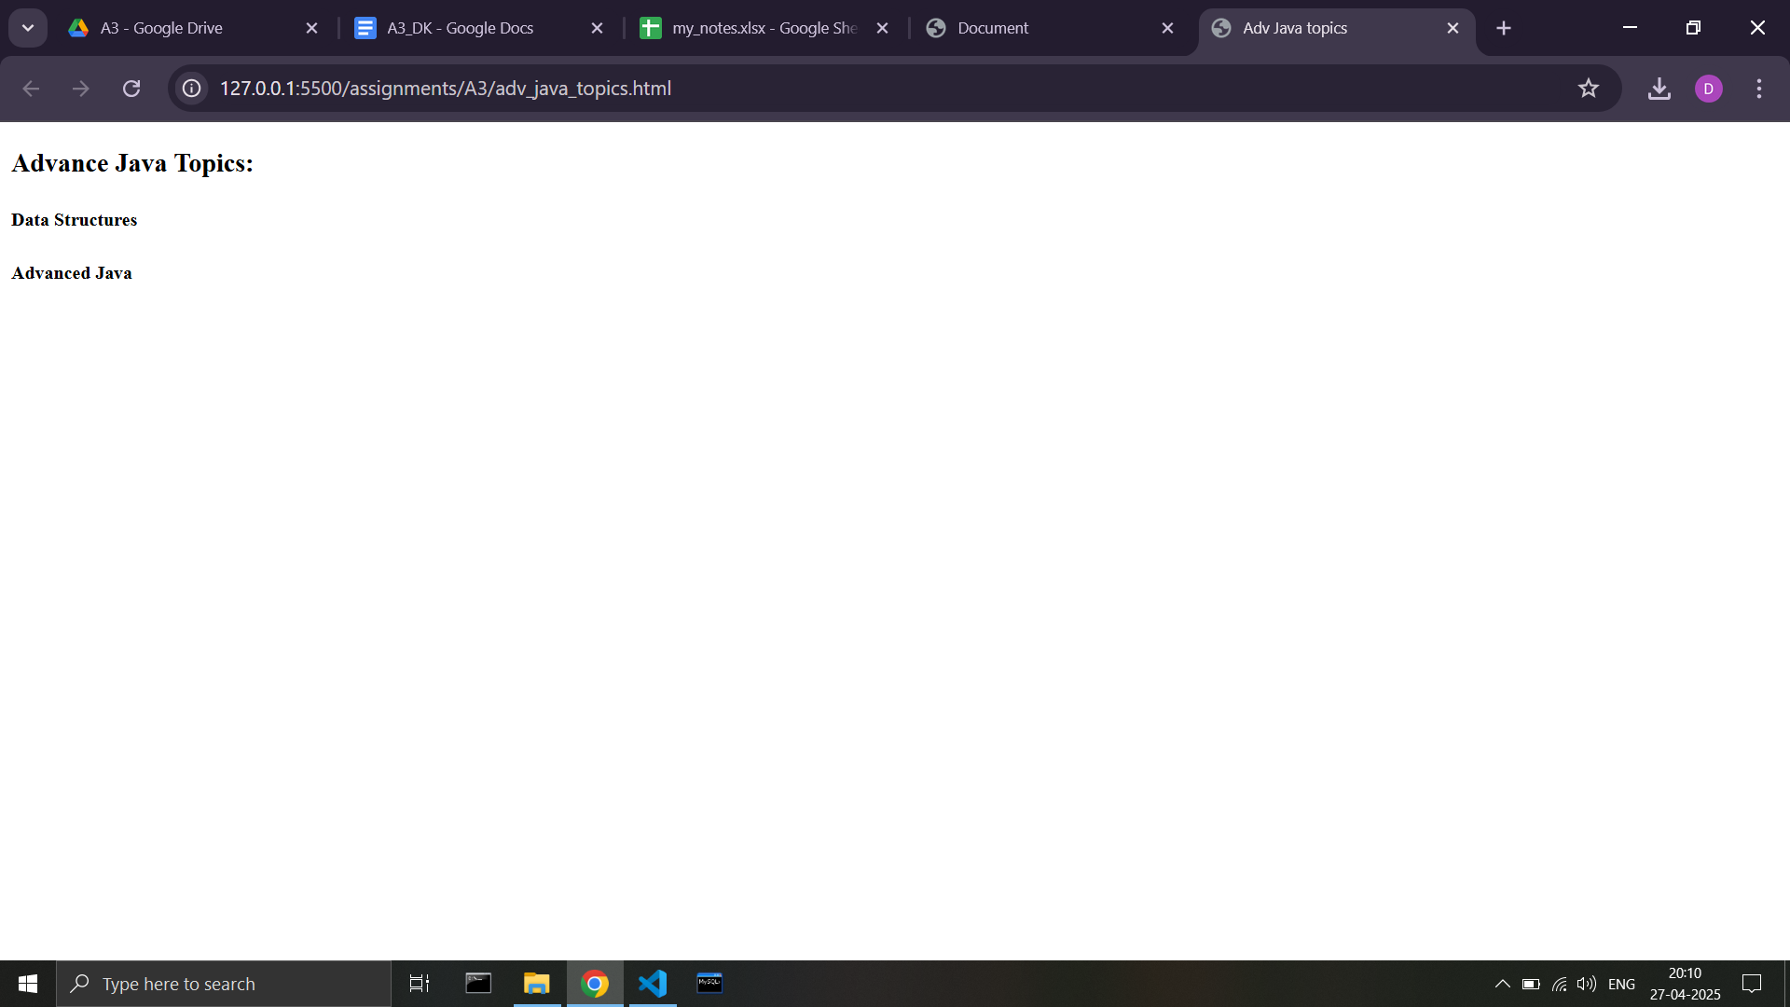

**Code -**

**<!DOCTYPE html>**

**<html lang="en">**

**<head>**

**<meta charset="UTF-8">**

**<meta name="viewport" content="width=device-width, initial-scale=1.0">**

**<title>Adv Java topics</title>**

**</head>**

**<body>**

**<h3>Advance Java Topics:</h3>**

**<h5>Data Structures</h5>**

**<h5>Advanced Java</h5>**

**</body>**

**</html>**

**Python Topics page -**

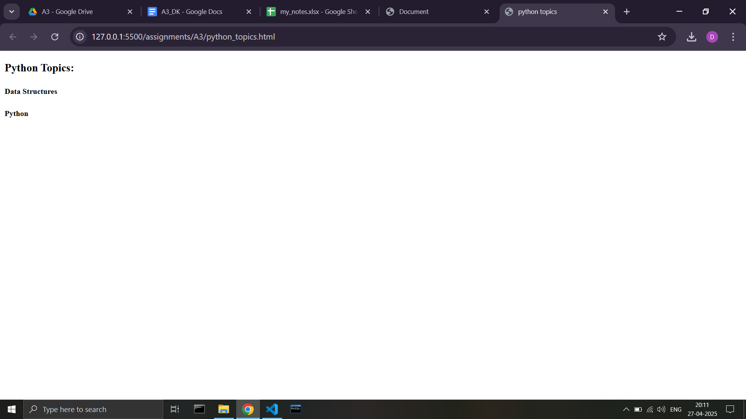

**Code -**

**<!DOCTYPE html>**

**<html lang="en">**

**<head>**

**<meta charset="UTF-8">**

**<meta name="viewport" content="width=device-width, initial-scale=1.0">**

**<title>python topics</title>**

**</head>**

**<body>**

**<h3>Python Topics:</h3>**

**<h5>Data Structures</h5>**

**<h5>Python</h5>**

**</body>**

**</html>**